lApplication Decommissioning Requirements and Planning Guide
for
2918/CCRF Agent Center
Approved on mm/dd/2026

Table of Contents
Executive Summary 3
Application Overview 6
Decommissioning Approach 8
Business Requirements 9
Records Retention Requirements 10
Legal/Contractual Requirements 12
Organization Change Management (OCM) 13
Operational / Technology Review 14
Sign Off 18
Document History 19
Appendix 20

Executive Summary

Application Overview
Commercial Change Request Form (CCRF) is a web app that was built to allow agents to submit amendment details for PCIO mainframe accounts. There is no direct connection to the PCIO mainframe systems, it relies on the user to manually enter details. When the amendment details are complete and the user submits the request, a PDF document is created based on the data entered. The submitted PDF document gets picked up by eFile, then a processor would take the details in the PDF and manually key the changes into the PCIO mainframe systems.

Historic Data Requirements
The web app utilized a SQL Server database (PPH4DD001) to store the details keyed by the user. When an amendment was submitted by the user, the details were put into a PDF document for a processor to then manually key the information into the PCIO mainframe systems. The details manually keyed into the PCIO mainframe system are the ultimate record of the amendment, not the SQL Server database. There will be no retention/archival needs related to the SQL Server database.

Timeline for Decommissioning
Task | Date | Notes
Review and get agreement on when the web app can be turned off | XX/XX/2026 | Confirm a date when CCRF can be turned off.
Any OCM activities? | N/A
Fully analyze/document web app components that will be decommissioned | 02/12/2026 | Complete
Reach out to Agent Center team to see if they will have any changes needed when the app is turned off | XX/XX/2026 | Does Agent Center have any standalone links into CCRF or is only an option on My Accounts for existing PCIO accounts? Sent email to Mark Marrano & Tom Murrane on 2/24.
Since CCRF is built/deployed with COI & CRN as CommServicing, determine what would need to be done to stop CCRF from being built but make sure to not break the ability to build/deploy COI & CRN | XX/XX/2026 | CCRF shares a Git repository and has always been built/deployed together with COI & CRN as “CommServicing”. Recommend having the House Band development line dig into the build/deploy logic to figure out how to turn off CCRF while not impacting the ability to build/deploy COI & CRN.
Turn off CCRF | XX/XX/2026 | Assuming House Band will turn off like it has for other CIS apps
Historical data archive/retention requirements agreed upon | N/A | The app’s database is not the ultimate source of record for amendments, so there will be no data retention/archival related to CCRF.
Remove CCRF from Qualys | XX/XX/2026 | When this was done for CIQ back in 2025, Brooke Gahring helped remove from Qualys. Once CCRF has been turned off, see if she can do the same for removing CCRF.
Notify eFile team that CCRF will no longer be sending documents | 02/24/2026 | Intake request CSS-1459-2026 has been submitted to eFile team to make them aware that their listener process for pulling in amendment detail PDFs from CCRF will no longer be needed after CCRF is turned off. This is similar to what they did when CIQ was turned off. CSS Intake - CSS-1459-2026 _ Legacy CCRF (2918) app is scheduled to be turned off in June 2026_ after that CCRF amendment docum.msg
Develop and execute on any data archive/retention tasks identified | N/A | Not needed for CCRF.
Decommission complete for the web application | XX/XX/XXXX

Application Overview

Application Functionality
Commercial Change Request Form (CCRF) is a web-based application providing the ability for agents to submit amendment or cancel information for PCIO mainframe accounts. The app has no direct connection to the PCIO mainframe systems. The user is required to manually key the details of the amendment or cancellation. When they are done and they submit the amendment, a PDF document gets created based on the details entered. The PDF gets picked up by eFile, then a processor takes the information in the PDF and manually keys the information into the PCIO mainframe CICS screens.

When keying amendment details, the user had the option to enter information for
- General Information
- Comments & Attachments
- Insured Information
- Additional Insured/Third Party
- Driver Information
- Auto – Vehicle Description/Limits
- Workers Compensation Rating
- Premises Information
- Property/Inland Marine – Premises
- Inland Marine/Scheduled Equipment
- Farm Recreation Vehicles
- Farm Livestock
- Farm – Scheduled (Household)/Unscheduled Farm Personal Property
- General Liability – Limits
- General Liability Schedule of Hazards
- Umbrella

For cancellations, the user had screens to enter
- General Information
- Cancellation

Ownership
Owner’s Name | Organization | Role | Contact Information
Colleen Esposito | CLS | App Owner

Run Costs (Decision was made that it wasn’t worth the effort to try to isolate costs.)
Expense Type | Annual Cost
Run Support | $
Licensing Fees | $ 0
Server H/W & OS S/W | $
Database Admin, Storage & Backup | $
Miscellaneous | $ 0
TOTAL | $

Decommissioning Approach

Overall Approach
- Analyze/document items in component inventory spreadsheet. (Done)
- CCRF is bundled together with two other apps (COI & CRN) under the common name CommServicing. Have the House Band development line that supports the app investigate what it will take to turn off CCRF without impacting the other two apps.
- When a date has been decided on turning off CCRF, make Agent Center team aware so that they can remove links into it.
- Have House Band development line stop the web application (test & production) and clean up the build/deployment/cloud/....Be careful since CCRF is bundled under CommServicing. Make sure to not impact COI and CRN
- Have House Band development line look into Certificates???? Are these specific to CCRF or shared across CommServicing????
- Let eFile team know when app has been turned off so that they can stop processing documents being sent to the /Prod/CCRF directory.
- Revoke generic IDs specific to web application. Refer to Component Inventory spreadsheet Be careful with generic IDs. Don’t revoke any that are shared across the CommServicing apps
- Change Git repository to “archive” to make it read-only Need to see if possible to do anything with the CCRF code since it is in a shared repository. Can just the CCRF piece get marked as archived or does it need to stay active since bundled under CommServicing with COI & CRN?
- Cleanup Splunk and New Relic items specific to the application. Refer to Component Inventory
- Reach out to Qualys team (Brooke Gahring helped with CIQ) to have them stop the test specific to CCRF
- Work with DBAs on deleting SQL Server database PH4DD001. After app is turned off, send in DBA request asking if they can see if anyone or any system has tried to access the database. Once usage is resolved, then submit DBA request asking them to initially rename the database and then if no one complains in 30 days go forward with deleting the database.

Approach to Retaining Historical Data / View
Since the CCRF database is not the ultimate source of record and the actual amendment details are keyed in the PCIO policy systems, there are no data retention or archive needs related to the CCRF database. The PH4DD001 database can be deleted after the web app is turned off.

Business Requirements

Historic Data Retention and Access Requirements
Req ID | Requirement Description | Notes
 | N/A | CCRF data does not need retained

Functionality Retention Requirements
Req ID | Requirement Description | Notes
 | N/A

Non-Functional Requirements
Req ID | Requirement Description | Notes
 | N/A

Records Retention Requirements
Retention Record Class Code | Record Class Name | Retention Period | Shutdown Date** | Destroy Date** | Documentation Location
 | N/A

Business Function(s)

Per meeting with business stakeholders (Rachel Barone, Minal Patel on 4/9/2026) this application will no longer be needed once all policies are expired on PCIO. Last policy expiration date is 5/1/2026.

Information Systems Business Function
Retention Record Class code | Record Class Name | Retention Period | Shutdown Date** | Destroy Date*** | Documentation Notes
TEC100 | Application Documentation and Source Code | 1 year | X/X/2026 |  | Source code - https://github.nwie.net/Nationwide/cis_commservicing Take caution with any actions done to this repository as it is a shared repository used by CCRF, COI, and CRN. Any actions taken related to CCRF need to makes sure not to impact COI & CRN.
TEC110 | Business Continuity and Disaster Recovery | 6 years |  |  | Archer
TEC130 | Systems Technical Administration | MAX3 Years |  |  | ServiceNow, Jira
TEC140 | Technical Support Requests | 3 years |  |  | ServiceNow
TEC150 | Website Activity Logs | 6 months |  |  | Splunk log retention is only available for 90 days  New Relic automatically removes items after 90 days
TEC165 | Information Risk Assessments and Findings | 5 years |  |  | Archer
TEC185 | Certificates | 13 months |  |  | Be careful around certificates. If they are shared CommServicing certificates, then don’t clean up as COI & CRN will still be active apps. Only do any cleanup if there are certificates specific to CCRF.

Legal/Contractual Requirements

Software Licensing
N/A

3rd Party Services
N/A

Supporting Software Tools’ Licensing
N/A

Infrastructure Software / Stack Components
N/A

Organization Change Management (OCM)

Application Knowledge Retention
House Band development line took over support of CIS apps that had previously been done by the Chaos Monkeys development line. They have working knowledge of CCRF, along with the knowledge how CCRF is bundled with COI & CCRF under the common name CommServicing. As CCRF gets turned off, need to be extremely careful not to do anything that impacts the COI or CRN web apps.

Workforce Planning
CCRF retirement has been a part of the ongoing plan of getting off legacy systems. Work has already transitioned to using the go-forward CL PolicyCenter platform, so changes of responsibilities and processes related to go-forward are already in place.

Operational / Technology Review

Conceptual Diagram

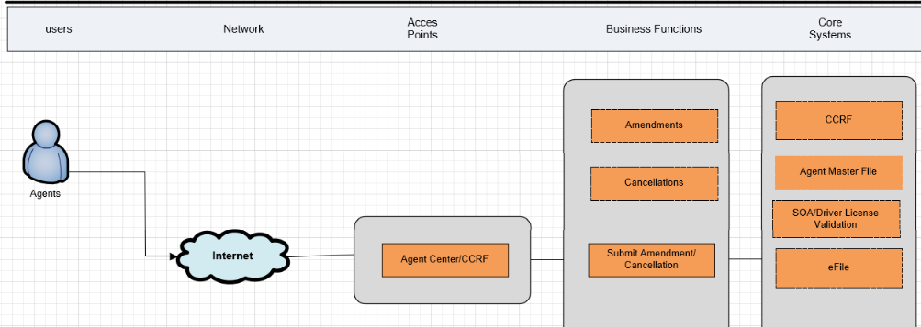

Stakeholders
Stakeholder Name | Organization | Role | Contact Information
Colleen Esposito | CLS BSA | SEPM
Scott Grau | CLS BSA | Architect
Bill Mardis | CLS BSA | Technical Lead
Angie Pike | CLESS | Bus. Delivery Executive

Integrations / System Context Diagram

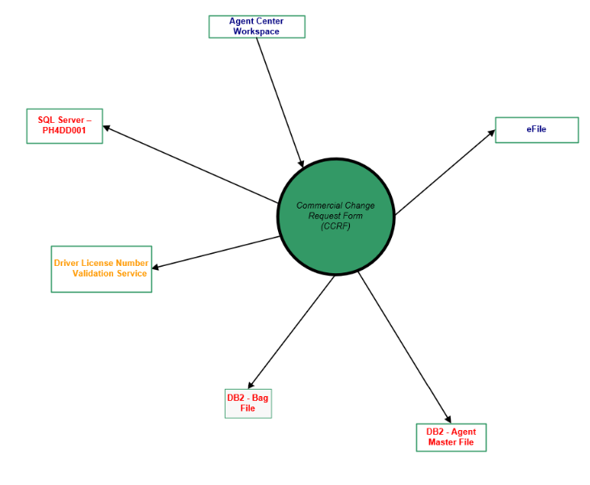

Integration Partner ID | Name | Consumer / Provider | Service Name | Type of Data Exchanged
6037 | Agent Center Workspace | Provider |  | Provides link into CCRF. Does user authentication.
 | eFile | Consumer |  | When amendments are submitted, PDF documents are created containing the amendment details and the document gets sent to a location using SFTP. eFile team has process that listens for new documents and pulls them in so that Processing can use the details to key into the PCIO mainframe systems.
993 | Agent Masterfile | Provider |  | Mainframe DB2 Agent Masterfile tables are queried to get agent information
 | Bag File | Provider |  | Mainframe DB2 query against Bag File to get underwriting and processing location
 | Driver License Validation Service | Provider |  | Through SOA a Driver License Validation service is called if they are entering an amendment that involves driver license number
 | SQL Server PH4DD001 |  |  | SQL Server database used by the web app

Nationwide Process Integration
Nationwide Process ID | Process Name
 | ServiceNow
 | New Relic
 | IIQ
 | Vault
 | Archer

Technology Platform
Technology Type | Technology Name | Notes
Operating System
Application Server | AWS/Cloud
DBMS / File Type | SQL Server | Reads and writes data to SQL Server database PH4DD001.
Coding Language | Java
3rd Party S/W | N/A
Source Management System | Github | https://github.nwie.net/Nationwide/cis_commservicing Take caution with any actions done to this repository as it is a shared repository used by CCRF, COI, and CRN. Any actions taken related to CCRF need to make sure not to impact COI & CRN.

Sign Off

Reviewers
Name | Organization | Function / Role | Review Date
Angie Pike | CLESS | Business | 4/9/2026

Approvers
Name | Organization | Function / Role | Approval Date
Rachel Barone | CL Processing Operations | Director
Minal Patel | CL Servicing Operations | Specialist
Katie Blaha | CL Servicing Operations | Director
Angie Pike | CLESS | Business | 4/22/2026

Document History
Version | Date | Author | Summary of Changes | Document Location
1.0 | 2/2/2026 | Bill Mardis | Document started

Appendix

